**React Native ActivityIndicator**

This post will Give you an Understanding of React Native ActivityIndicator. React Native ActivityIndicator is a component for displaying loading action. It is the same as the circular loader/Progress Bar. It is used to show the progress of long-running task so that the user can understand something is in progress.

 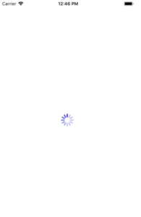

//This is an example code to understand ActivityIndicator//

import React, { Component } from 'react';

//import react in our code.

import { ActivityIndicator, Button, View, StyleSheet } from 'react-native';

//import all the components we are going to use.

export default class App extends Component {

  constructor() {

    super()

    this.state = {

      showIndicator: false

    }

  }

  onButtonPress = () => {

    //function to change the state to true to view activity indicator

    this.setState({

      showIndicator: true

    });

  }

  render() {

    //Check if showIndicator state is true the show indicator if not show button

    if (this.state.showIndicator) {

      return (

        <View style={styles.container}>

          {/*Code to show Activity Indicator*/}

          <ActivityIndicator size="large" color="#0000ff" />

          {/*Size can be large/ small*/}

        </View>

      );

    } else {

      return (

        <View style={styles.container}>

          {/*On CLick of a button onButtonPress will bw called will change the state*/}

          <Button onPress={this.onButtonPress} title='Click to see Indicator' />

        </View>

      );

    }

  }

}

const styles = StyleSheet.create({

  container: {

    flex: 1,

    justifyContent: 'center',

    flexDirection: 'column'

  }

});